Important Items about Congress
You need to begin familiarizing yourself with these terms. You will be having an identification quiz at the halfway point of the Unit. Remember, the quiz has no word bank, you must know these terms.

bicameral legislature  bill  casework  caucus  committee chairs  conference committees  filibuster  House Rules Committee | incumbents  joint committees  legislative oversight  majority leader  minority leader  pork barrel  select committees
Congress

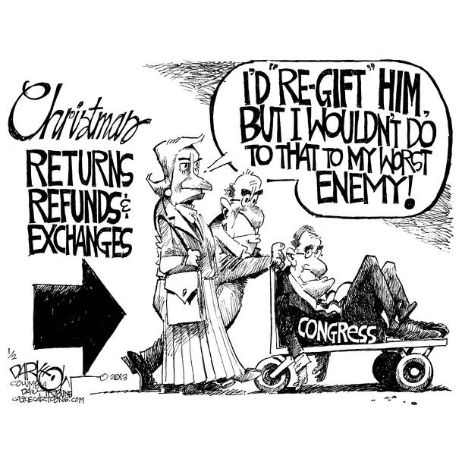
http://img.allvoices.com/thumbs/image/609/609/95824877-re-gifting-congress.jpg
Learning Objectives (you should be able to answer these by the time we finish the Unit)
- Describe the essential roles and functions of a senator and representatives.

- List the characteristics of a “typical” member of Congress.

- Identify the advantages of incumbency in the congressional election process.

- Examine the role of money in congressional elections-where it comes from, how it is used, and what influence or effect it has.

- Summarize both the advantages and disadvantages of the growing influence of PACs.

- Contrast organizational style and procedures in the House of Representatives with those of the Senate.

- Identify the major leadership positions in the House and Senate and summarize the functions of each office.

- Review the four types of congressional committees and explain how they control the congressional agenda and guide legislation.

- Determine the significance of legislative procedures like the filibuster and oversight.

- Outline the process by which a bill would move through the legislative process, from introduction to the point where it is sent to the president.

- Contrast three theories of the role of a legislator: trustee, instructed delegate, and politico.

- Appraise the influence of lobbyists and interest groups on the legislative process.

- Identify both representative and unrepresentative aspects of Congress.

- Examine the effect that the U.S. Congress has had on the scope of government.

