The Civil Rights Movement (Ch. 39)
1960-1968

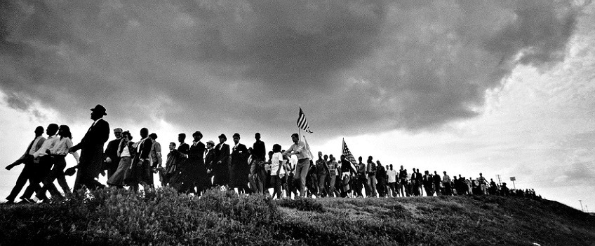
James Karales (1930-2002), Selma-to-Montgomery March for Voting Rights in 1965.

Important Items about the Civil Rights Movement
You need to begin familiarizing yourself with these terms. You will be having an identification quiz at the halfway point of the Unit. Remember, the quiz has no word bank, you must know these terms.

Significant Events  Greensboro sit-ins, 1960  Freedom Riders, 1961  Birmingham, Alabama, 1963  March on Washington, 1963  Mississippi Summer Project, 1964  Civil Rights Act of 1964  Malcolm X assassinated, 1965  March from Selma to Montgomery, 1965  Voting Rights Act of 1965  Riots in Watts, California, 1965  Civil Rights Act of 1968  Martin Luther King assassinated, 1968 | Important People  Martin Luther King  Elijah Muhammad  Malcolm X  James Meredith  Stokely Carmichael  George Wallace  Thurgood Marshall | Additional Information  Jim Crow Laws  de jure segregation  de facto segregation  SCLC  CORE  SNCC  Nation of Islam (Black Muslims)  Black Panthers  busing (regarding schools)  affirmative action

