The Great Depression and New Deal (Ch. 33-34)
1930-1940

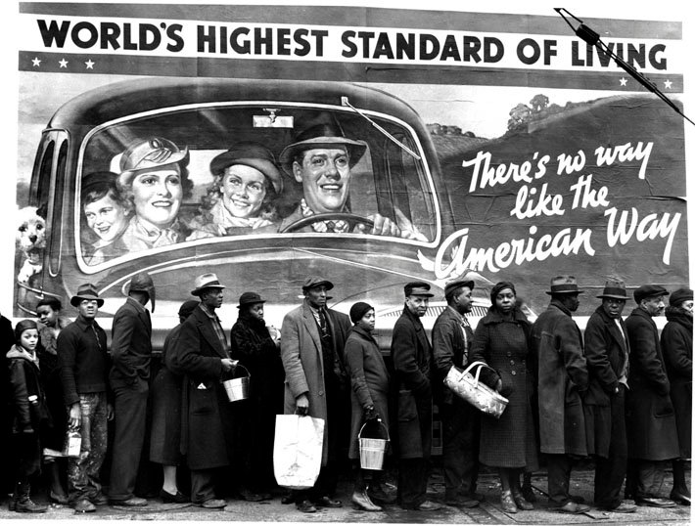

“At The Time of the Louisville Flood” (1937) – Margaret-Bourke White

Boom and Bust (Ch. 33) Essential Questions
- Analyze the domestic political conservatism and economic prosperity of the 1920s.
- Explain the Republican administrations’ policies of isolationism, disarmament, and high-tariff protectionism.
- Compare the easygoing corruption of the Harding administration with the straight-laced uprightness of his successor Coolidge.
- Describe the international economic tangle of loans, war debts, and reparations, and indicate how the United States dealt with it.
- Discuss how Hoover went from being a symbol of twenties business success to a symbol of depression failure.
- What caused the stock market crash?
- Explain how the stock-market crash set off the deep and prolonged Great Depression.
- Indicate how Hoover’s response to the depression was a combination of old-time individualism and the new view of federal responsibility for the economy.
- What was the Bonus Army? Describe what happened at the protest they staged?

Great Depression and New Deal (Ch. 34) Essential Questions
- Describe the rise off Franklin Roosevelt to the presidency in 1932.
- What were the characteristics of the Great Depression?
- Explain how the early New Deal pursued the “three Rs” of relief, recover, and reform.
- Describe the New Deal’s effect on labor and labor organizations.
- Discuss the early New Deal’s efforts to organize business and agriculture in the NRA and the AAA and indicate what replaced those programs after they were declared unconstitutional.
- Describe the Supreme Court’s hostility to many New Deal programs and explain why FDR’s “court packing” plan failed.
- Explain the political coalition that Roosevelt mobilized on behalf of the New Deal and the Democratic Party.
- What was the Dust Bowl, and how was it created?
- Discuss the changes the New Deal underwent in the late thirties and explain the growing opposition to it.
- Analyze the arguments presented by both critics and defenders of the New Deal.

Important Items about Great Depression and New Deal
Make sure you are familiar with these various items. They will show up on tests/quizzes/discussions.

Significant Events  Stock market crash, 1929  Hawley-Smoot Tariff, 1930  Reconstruction Finance, Corporation, 1932  Bonus March, 1932  First New Deal (First Hundred Days), 1933  Bank Holiday, 1933  Federal Deposit Insurance Corporation, 1933  Civilian Conservation Corps, 1933  Public Works Administration, 1933  Agricultural Adjustment Act, 1933  Tennessee Valley Authority, 1933  Federal Emergency Relief Administration, 1933  National Recovery Administration, 1933  Securities and Exchange Commission, 1934  Second New Deal (Second Hundred Days), 1935  Works Progress Administration, 1935  National Youth Administration, 1935  Rural Electification Administration, 1935  Wagner Act, 1935  Social Security Act, 1935  Schecter v. United States, 1935  Huey Long assassinated, 1935 | Important People  Warren G. Harding  Calvin Coolidge  Herbert Hoover  Franklin Roosevelt  Douglas MacArthur  John L. Lewis  Charles Coughlin  Huey Long  Francis Townsend  Francis Perkins | Additional Information  Black Tuesday  Rugged individualism  Hooverville  New Deal  Brain Trust  Relief, Recover, Reform  Blue Eagle (“We Do Our Part”)  New Deal Coalition  Share-Our-Wealth  Dust Bowl

