The Progressive Era
1890-1920

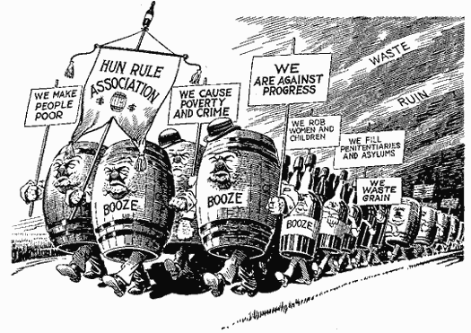
Chapter 29: Progressivism and the Republican Roosevelt
1. Discuss the origins and nature of the progressive movement.

2. Describe how the early progressive movement developed its roots at the city and state level.

3. Identify the critical role that women played in progressive social reform.

4. Tell how President Roosevelt began applying progressive principles to the national economy.

5. Explain why Taft’s policies offended progressives, including Roosevelt.

6. Describe how Roosevelt led a progressive revolt against Taft that openly divided the Republican
party.

Chapter 30: Wilsonian Progressivism at Home and Abroad
1. Discuss the key issues of the pivotal 1912 election and the basic principles of Wilsonian
progressivism.

2. Describe how Wilson successfully reformed the “Triple wall of privilege.”

3. State the basic features of Wilsons’s foreign policy and explain how they drew him into intervention
in Latin America.

4. Describe America’s response to World War I and explain the increasingly sharp conflict over
America’s policies toward Germany.

5. Explain how domestic and foreign controversies played into Wilson’s narrow victory over Hughes in
1916.

Important Items about Progressivism
Briefly describe each of the items below.

Significant Events | Important People | Additional Info
Munn v. Illinois, 1877 | Theodore Roosevelt | Social Gospel
Wabash v. Illinois, 1886 | William H. Taft | Charles Sheldon, In His Steps
Interstate Commerce Act, 1887 | Woodrow Wilson | muckraker
Sherman Antitrust Act, 1890 | Eugene V. Debs | Jacob Riis, How the Other Half Lives
McKinley assassinated, T. Roosevelt becomes president, 1901 | Robert LaFollette | Lincoln Steffens, Shame of the Cities
Roosevelt mediates coal strike, 1902 | Susan B. Anthony | Ida Tarbell, History of the Standard Oil Company
Wright brothers fly first airplane, 1903 | Jane Addams | Upton Sinclair, The Jungle
Roosevelt breaks up Northern Securities Company, 1904 | Lillian War | Square Deal
Industrial Workers of the World created, 1905 |  | conservation
Meat Inspection Act, 1906 |  | Progressive “Bull Moose” Party
Pure Food and Drug Act, 1906 |  | New Nationalism
Payne-Aldrich Tariff, 1909 |  | New Freedom
Ballinger-Pinchot controversy, 1909 |  | Sixteenth Amendment
Election of 1912 |  | Seventeenth Amendment
Underwood Tariff, 1913 |  | Eighteenth Amendment
Federal Reserve System created, 1913 |  | Nineteenth Amendment
Federal Trade Commission, 1914
Clayton Anti-Trust Act, 1914

