The Roaring Twenties (Ch. 32)
1920-1929

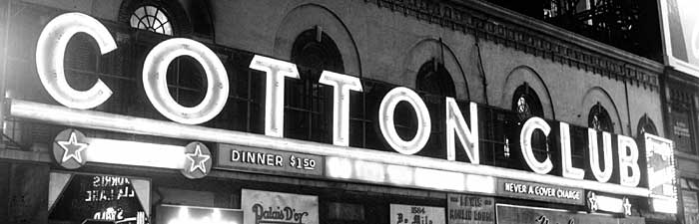

The Cotton Club was a cultural center in Harlem, as both whites and African Americans came to see acts such as Duke Ellington and Cab Calloway during the 1920s and 1930s. [Michael Ochs Archives/Getty Images]

Essential Questions (you should be able to answer these by the time we finish the Unit)

- Analyze the movement toward social conservatism following World War I.

- What happened during the Red Scare after World War I?

- Describe the cultural conflicts over such issues as prohibition and evolution.

- What effect did the prohibition of alcohol have on the United States?

- What was the Scopes trial?

- Discuss the rise of the mass-consumption economy, led by the automobile industry.

- Describe the cultural revolution brought about by radio, film, and changing sexual standards.

- Explain how new ideas and values were reflected and promoted in the American literary renaissance of the 1920s.

- Explain how the era’s cultural changes affected women and African-Americans.

Important Items about The Roaring Twenties
Make sure you are familiar with these terms; they will show up on quizzes and tests.
Some of these will be in the textbook, others you will need to look up on ABC Clio.

Significant Events  Volstead Act, 1919  Palmer Raids, 1919-1920  First commercial radio broadcast (KDKA in Pittsburgh), 1920  National Origins Act, 1924  Teapot Dome scandal, 1924  Scopes Trial, 1925  Ku Klux Klan marches on Washington, 1925  Sacco and Vanzetti executed, 1927  Charles Lindbergh flies from New York to Paris, 1927  The Jazz Singer, 1927 | Important People  Warren G. Harding  Calvin Coolidge  Herbert Hoover  Al Smith  J. Edgar Hoover  Andrew Mellon  Harry Dougherty  Albert Fall  William Jennings Bryan  Clarence Darrow  Marcus Garvey  Louis Armstrong  Bessie Smith  George Gershwin  Sinclair Lewis  F. Scott Fitzgerald | Additional Information  “Old Guard” Republicans  “return to normalcy”  Ohio gang  “soak-the-poor” taxes  Bootlegger  Speakeasy  Twenty-First Amendment  Fundamentalism  Modernism  Flapper  Harlem Renaissance

