Important Items about Interest Groups
You need to begin familiarizing yourself with these terms. You will be having an identification quiz at the halfway point of the Unit. Remember, the quiz has no word bank, you must know these terms.

actual group  amicus curiae briefs  class action lawsuits  collective good  electioneering  elite theory  free-rider problem  hyperpluralist theory  interest group  lobbying | Olson’s law of large groups  pluralist theory  political Action Committee  potential group  public interest lobbies  right to work laws  selective benefits  single-issue group  subgovernments  Union shop
Interest Groups

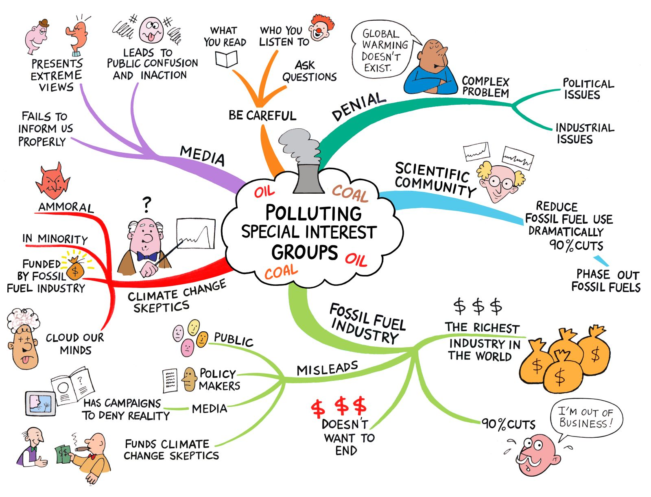
http://sagebrushsolar.com/wp-content/uploads/2012/04/skeptics.jpg
Learning Objectives (you should be able to answer these by the time we finish the Unit)
- Distinguish the essential differences between interest groups and political parties.

- Understand 3 basic theories of interest group politics: pluralist, elite and hyperpluralist.

- Examine how interest group liberalism may be promoted by the network of subgovernments (or “iron triangles”) in the American political system..

- Determine the factors that tend to make an interest groups successful.

- Differentiate between potential group and an actual group and determine how the free-rider problem applies.

- Explain how interest groups try to shape public policy.

- Determine how lobbyists represent interest groups in influencing legislative agenda.

- Distinguish among the various forms of interest groups, such as economic and public interest groups.

- Explain why the authors of the textbook say that the problems of honest lobbying now appear to outweigh the traditional problems of dishonest lobbying.

- Summarize the implications for the size of government that are generated by the power of PACs and special interest groups.

- Analyze the appropriate role of interest groups within a democratic environment.

