The Cold War and the Fifties (Ch. 37-38)
1945-1961

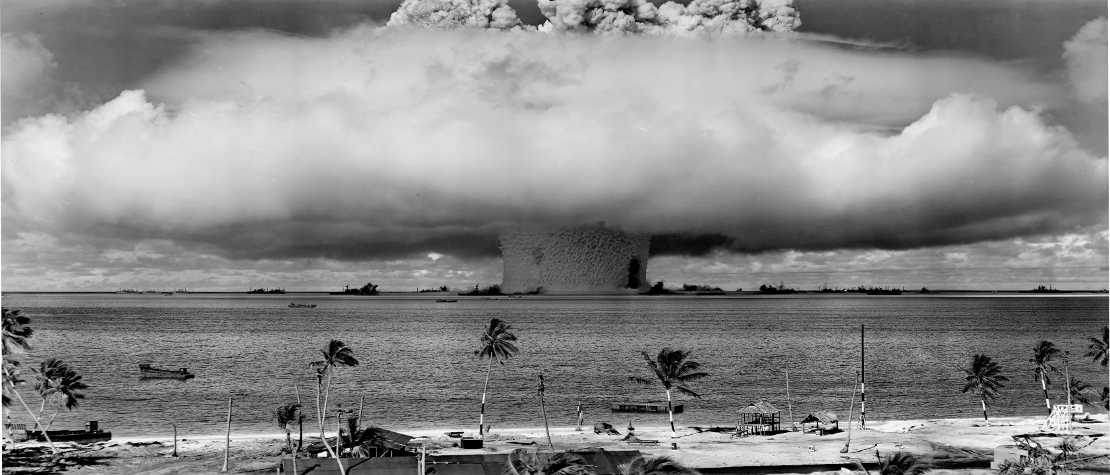

Operation Crossroads test of the underwater atomic bomb Baker at Bikini Atoll, 1946. Because of radioactive fallout from the testing, Bikini Atoll is still uninhabitable.

Chapter 37: The Cold War Begins
- Historical Interpretation: Analyze the reasons for the development of tensions between the Soviet Unions and the United States.

- Historical Argumentation: Analyze the degree of success the policy of containment achieved between 1945 and 1953.

- Historical Causation: Analyze the reasons for the growth of anti-labor sentiment following World War II?

- Historical Causation: Analyze the reasons for and results of the second Red Scare.

- Contextualization: Analyze the ways in which the United States prepared to avoid a serious economic recession following World War II.

- Comparison: Compare and contrast the response of the American people to the end of World War II to the American people’s response to the end of World War I.

- Contextualization: Analyze the political debates over the uses of atomic technology in the post-World War II era.

- Patters of CCOT: To what degree and in what ways did post World War II foreign policy represent a fundamental change from previous foreign policy.

Chapter 38: The Eisenhower Era
- Historical Causation: Analyze the reasons for the development of a prolonged and robust economy during the 1950s.

- Historical Interpretation: Analyze the factors that led to the homogenization of American society during the 1950s.

- Historical Argumentation: Analyze the reasons for the growth of the civil rights movement during the 1950s and the degree of success it achieved.

- Patterns of CCOT: Analyze the continuity and change in migration patterns in the United States during the 1950s.

- Comparison: Analyze the positive and negative effects of increased scientific and technological development during the 1950s.

- Historical Argumentation: Evaluate the reasons for and the success of American foreign policy during the 1950s.

- Contextualization: Analyze how mass media influenced traditional perceptions of gender roles during the 1950s

- Patterns of CCOT: To what degree and in what ways did post-World War II American society mirror poast-World War I society, politically?

Important Items about the Cold War
Remember, these will show up on quizzes, tests and discussions. You’re expected to know all of these.

Significant Events  United Nations established,1945  Churchill delivers Iron Curtain speech, 1946  Truman Doctrine, 1947  Marshall Plan, 1947  Taft-Hartley Act, 1947  Berlin Airlift, 1948  Creation of Israel, 1948  Alger Hiss case, 1948  NATO created, 1949  Soviet Union tests its first atomic bomb, 1949  Communists gain control of China, 1949  Joseph McCarthy accuses the State Department of employing communists, 1950  McCarran Internal Security Act passes over Truman’s veto, 1950  Korean War, 1950-1953  U.S. tests the first H-bomb, 1952  Joseph Stalin died, 1953  Julius and Ethel Rosenberg executed, 1953  Joseph McCarthy censured, 1954  Eisenhower Doctrine, 1957  Sputnik launched by the Soviet Union, 1957  U-2 shot down over the Soviet Union, 1960  Eisenhower’s Farewell Address, 1961 | Important People  Harry Truman  Dwight Eisenhower  George Kennan (Mr. X)  Douglas MacArthur  Chiang Kai-shek  Mao Zedong  John Foster Dulles  Nikita Khrushchev  Francis Gary Powers  Whitaker Chambers  Richard Nixon  Thomas Dewey  Strom Thurmond  Jonas Salk | Additional Information  Cold War  U.N. General Assembly  U.N. Security Council  Warsaw Pact  Policy of containment  Taiwan  status quo ante (how does this quote relate to the Korean War?)  brinksmanship  massive retaliation  peaceful coexistence  CIA  military-industrial complex (see Ike’s Farewell Speech)  Dixiecrats  HUAC  Hollywood Ten  blacklist  McCarthyism  Levitt town  baby boom  beatniks  rock ‘n’ roll

