Unit 1: Exploration, Colonization, and Early America (Ch. 1)
1491-1607

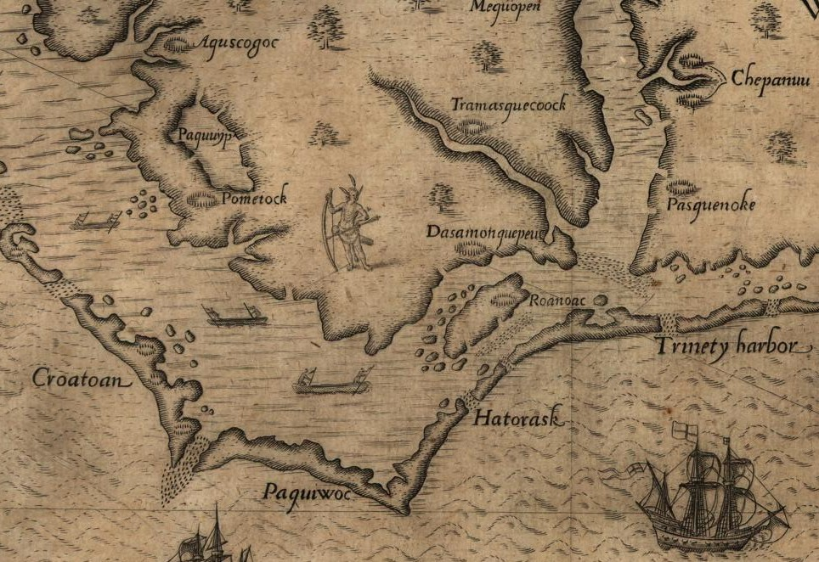

Above is a map of the Virginia coast. Just right of center, is the location of the lost colony of Roanoke.
(http://5z3udk.assets-01.cdndrive.com/wp-content/uploads/2012/04/Colonists_of_Roanoke.jpg)

Chapter 1: The Collision of Cultures
- Comparison: Compare the regional differences among Native Americans before the arrival of Europeans.

- Comparison: How did patterns of settlement differ among the Spanish, English, French, and Dutch immigrants?

- Historical Causation: What were the causes and effects of the beginning of importation of African slaves into the Americas?

- Periodization: Within the context of the time period, what was the impact of mercantilism on the European colonization of North America?

- Historical Causation: Identify the positive and negative impact of the Columbian Exchange on both European and native populations in North America.

Important Items about Exploration, Colonization, and Early America
You need to understand how the following people, places, and events demonstrate or relate to key concepts and historical themes found in the AP US History Curriculum Framework. These could be used as prompts for, or in an answer to the different types of questions that you’ll see; Multiple Choice, SAQ, DBQ, and Long Essay.

African Slave Trade  Algonquian  Atlantic World  Biological and Cultural  Cahokia  Catholic Missions (Spanish)  Charter Companies  Christopher Columbus  Conquistadores  Corn (Maze) Cultivation  Coureurs de Bois | Don Juan de Onate  Encomienda  Fur Trade  Henry Hudson  Iroquois  Jamestown  Matrilineal  Mercantilism  Meso-Americans  Mestizos  Pueblo Revolt | Puritans  Racial Hierarchy  Roanoke  Samuel de Champlain  Separatists  Sir Walter Raleigh  Smallpox  Tenochtitlan  Woodland Indians

