The Vietnam War (Ch. 39-40)
1965-1975

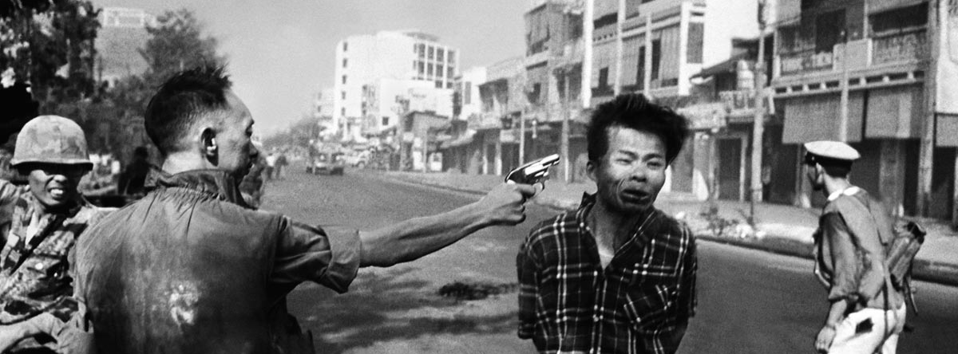
Street execution of a Viet Cong prisoner, Saigon, February 1968. (Photograph by Eddie Adams.)

Important Items about the Vietnam War
You need to begin familiarizing yourself with these terms. You will be having an identification quiz at the halfway point of the Unit. Remember, the quiz has no word bank, you must know these terms.

Significant Events  Battle of Dienbienphu, 1954  Geneva Accords, 1954  U.S. aid to South Vietnam begins, 1955  Ngo Dinh Diem assassinated, 1963  Tonkin Gulf Resolutions, 1964  U.S. ground troops arrive in Vietnam, 1965  Tet Offensive, 1968  My Lai massacre, 1968  Vietnamization begins, 1969  U.S. invasion of Cambodia, 1970  Kent State killings, 1970  U.S. invasion of Laos, 1971  Daniel Ellsberg leaks the Pentagon Papers, 1971  U.S. troops pulled out of Vietnam, 1973  War Powers Act, 1973  South Vietnam falls to communists, 1975 | Important People  Harry Truman  Dwight Eisenhower  John Kennedy  Lyndon Johnson  Richard Nixon  Gerald Ford  Henry Kissinger  Ho Chi Minh  Robert McNamara  Eugene McCarthy  Robert Kennedy  Hubert Humphrey | Additional Information  Domino theory  National Liberation front  Vietcong  ARVN  hawk  Dove  Search and destroy  Agent Orange  Napalm  Vietnam Veterans Against the War

