World War I (Ch. 31)
1914-1918

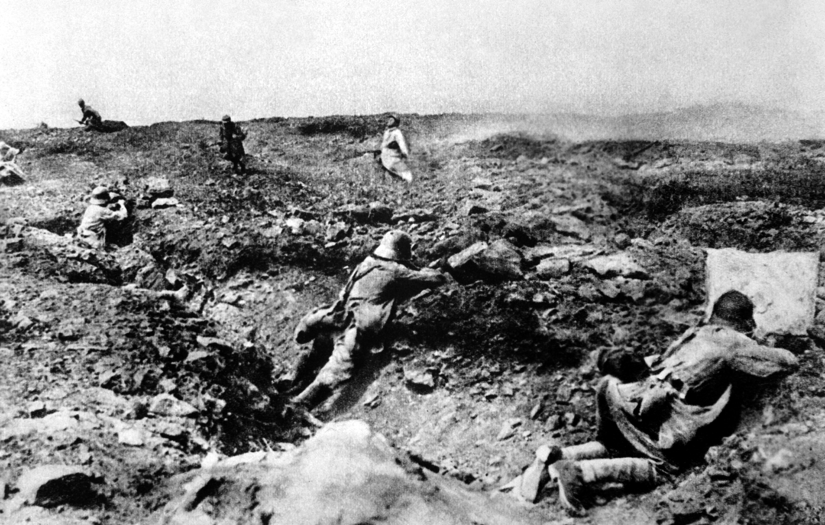
Looking at the photograph above, what observations can be made about the style of fighting during World War I?

Chapter 31 Learning Objectives
- Explain what caused America to enter World War I.
- Describe how Wilsonian idealism turned the war into an ideological crusade that inspired fervor and overwhelmed dissent.
- Discuss the mobilization of America for war.
- Explain the consequences of World War I for labor, women, and African-Americans.
- Describe America’s economic and military role in the war.
- Analyze Wilson’s attempt to forge a peace based on his Fourteen Points and explain why developments at home and abroad forced him to compromise.
- Discuss the opposition of Lodge and others to Wilson’s League and show how Wilson’s refusal to compromise doomed the Treaty of Versailles.

Important Items about World War I
You need to begin familiarizing yourself with these terms. You will be having an identification quiz at the halfway point of the Unit.

Significant Events  Archduke Franz Ferdinand assassinated, 1914  World War I begins, 1914  Wilson proclaims neutrality, 1914  Lusitania sinks, 1915  William Jennings Bryan resigns as Secretary of State, 1915  Sussex pledge, 1916  Pancho Villa raids Columbus, New Mexico, 1916  Zimmerman telegram, 1917  Germany resumes unrestricted warfare, 1917  U.S. enters World War I, 1917  World War I ends, 1918  Sedition Act, 1918  Treaty of Versailles, 1919 | Important People  Woodrow Wilson  General John J. Pershing  Robert Lansing (not in the text)  Henry Cabot Lodge | Additional Information  Restricted warfare  Unrestricted warfare  “He Kept Us Out of War”  American Expeditionary Force  Fourteen Points  League of Nations  Democratic internationalist (not in the text)  Republican “irreconcilables”  Republican reservationist (not in the text)

