World War II (Ch. 35-36)
1922-1946

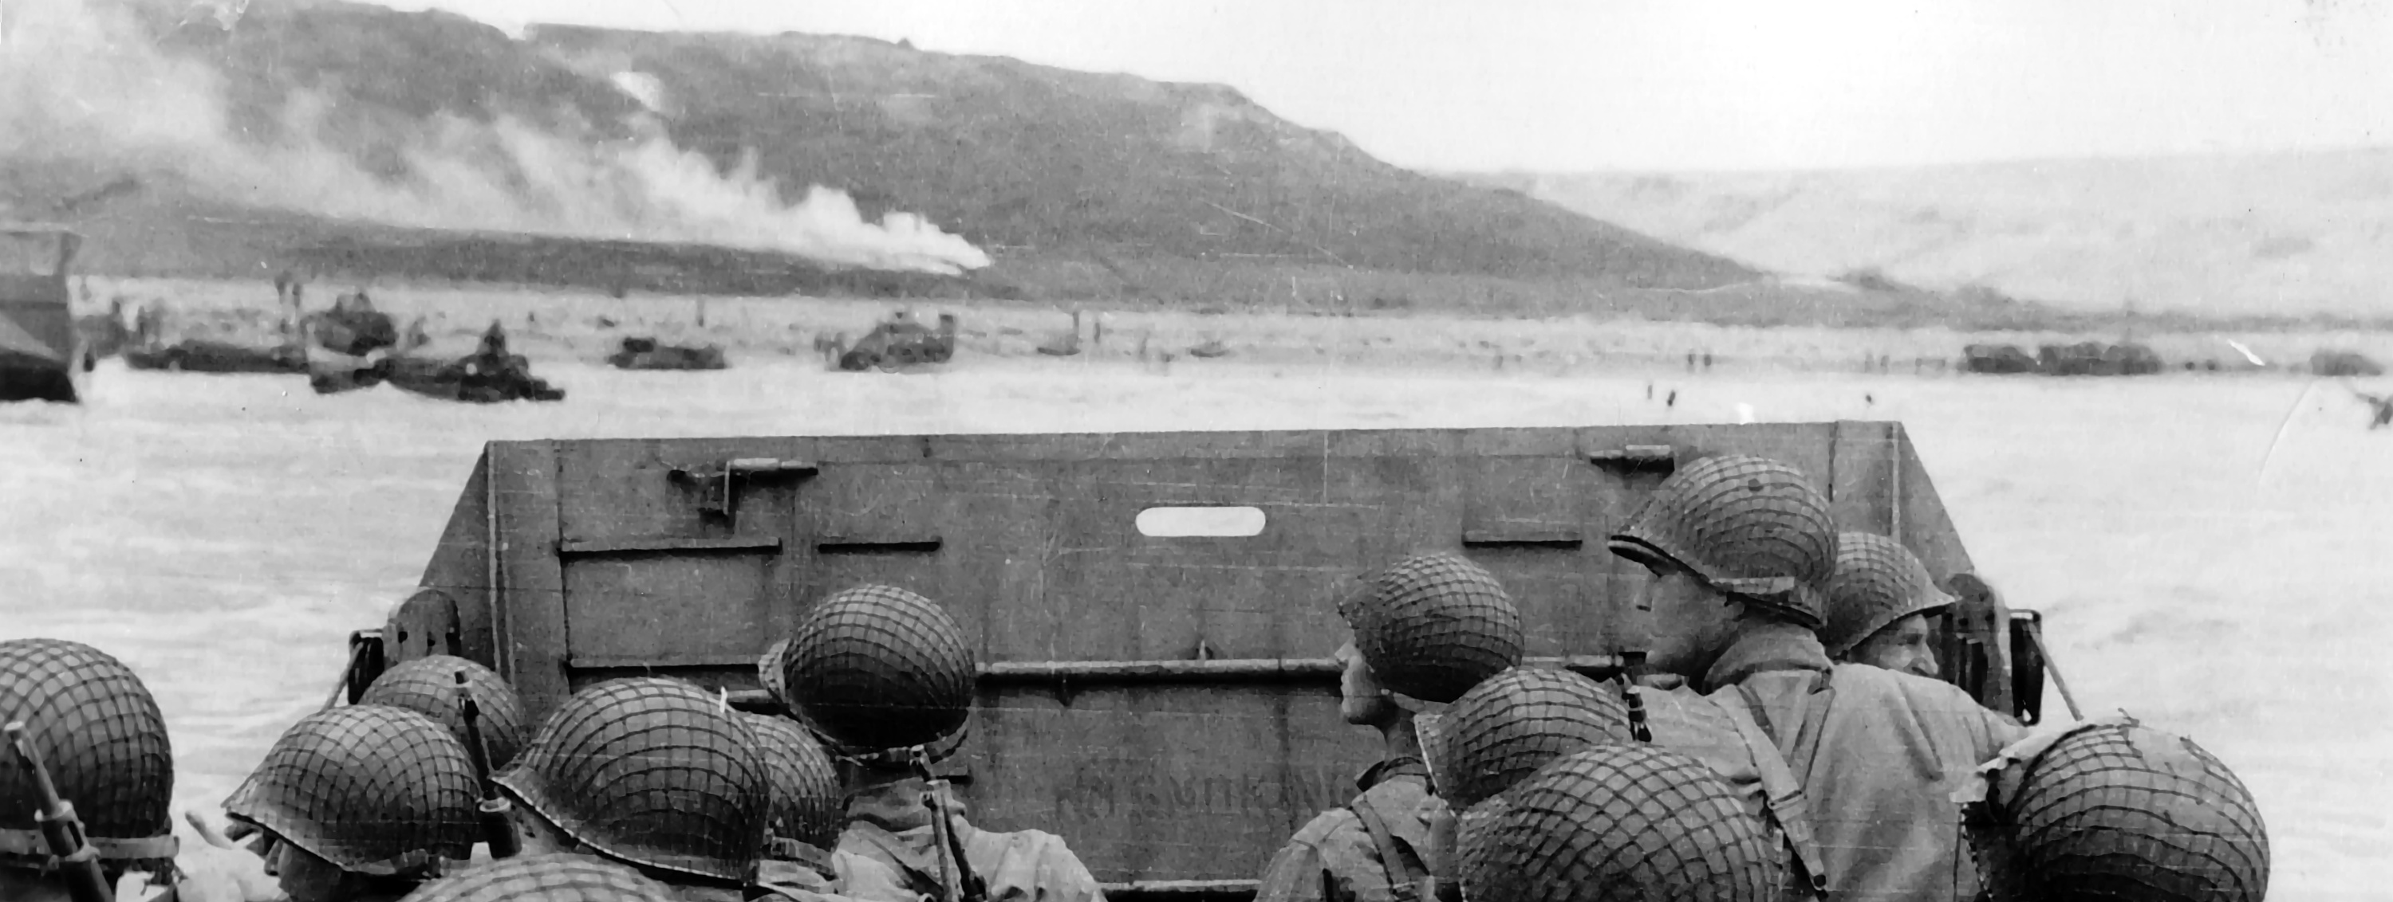

Troops in an LCVP landing craft approaching "Omaha" Beach on "D-Day", 6 June 1944.

Chapter 35: Franklin D. Roosevelt and the Shadow of War
- Describe the isolationist motives and effects of FDR’s early foreign policies.

- Explain how American isolationism dominated U.S policy in the mid-1930s.

- Explain how America gradually began to respond to the threat from totalitarian aggression while still trying to stay neutral.

- Describe Roosevelt’s increasingly bold moves toward aiding Britain in the fight against Hitler and the sharp disagreements these efforts caused at home.

- Discuss the events and diplomatic issues in the Japanese-American conflict that led up to Pearl Harbor.

Chapter 36: America in World War II
- Tell how America reacted to Pearl Harbor and prepared to wage war against both Germany and Japan.

- Describe the domestic mobilization for war.

- Describe the war’s effects on American society, including regional migration, race relations, and women’s roles.

- Explain the early Japanese successes in Asia and the Pacific and the American strategy for countering them.

- Describe the early Allied efforts against the Axis powers in North Africa and Italy.

- Discuss FDR’s 1944 fourth-term election victory, explaining what he won on, his opponents, running mate, and how he won.

- Explain the final military efforts that brought Allied victory in Europe and Asia and the significance of the atomic bomb.

Important Items about World War II
Remember, these will show up on quizzes, tests and discussions. You’re expected to know all of these.

Significant Events  Benito Mussolini becomes dictator of Italy,1922  Kellogg-Briand Pact, 1928  Stimson Doctrine, 1932  Good Neighbor Policy, 1933  Adolph Hitler becomes dictator of Germany, 1933  Nye Committee1934-36  Italy invades Ethiopia, 1935  Neutrality Acts, 1935-37  Germany occupies the Rhineland, 1936  Japan invades China, 1937  Germany occupies Austria, 1938  Munich Conference, 1938  Germany invades Czechoslovakia, 1939  Non-Aggression Pact, 1939  Germany invades Poland, World War II begins, 1939  Battle of Britain begins, 1940  Lend Lease Act, 1941  Germany attacks the Soviet Union, 1941  Atlantic Charter, 1941  Pearl Harbor attacked, U.S. entered World War II, 1941  Teheran Conference, 1943  Normandy invasion (D-Day), 1944  GI Bill of Rights, 1944  Yalta Conference, 1945  Germany surrenders, 1945  Potsdam Conference, 1945  Hiroshima and Nagasaki bombed, Japan surrenders, 1945 | Important People  Franklin Roosevelt  Harry Truman  Winston Churchill  Joseph Stalin  Charles DeGaulle  Benito Mussolini  Adolph Hitler  Hideki Tojo  George Marshall  Dwight Eisenhower  Douglas MacArthur  Clement Atlee  A. Philip Randolph  J. Robert Oppenheimer | Additional Information  Fascism  policy of appeasement  final solution  genocide  Axis powers  “arsenal of democracy”  Blitzkrieg  island hopping  Manhattan Project  Potsdam Declaration  Nuremberg trials  Rosie the Riveter  Rationing  Japanese-American internment

